PROJECT REPORT TEMPLATE
1 INTRODUCTION
1.1 Over view:
A visa slot management project is a system that is used to track and manage the availability of visaslots, which are appointments that are required for certain visa applications. It might be used by agovernment agency or a visa processing center to schedule and manage appointments with applicants.
1.2 Purpose:
A visa is an official document that allows the bearer to legally enter a foreign country. The visa is usually stamped or glued into the bearer’s passport. There are several different types of visas, each of which afford the bearer different rights in the host country.
2 Problem Definition & Design Thinking:
2.1 Empathy Map:
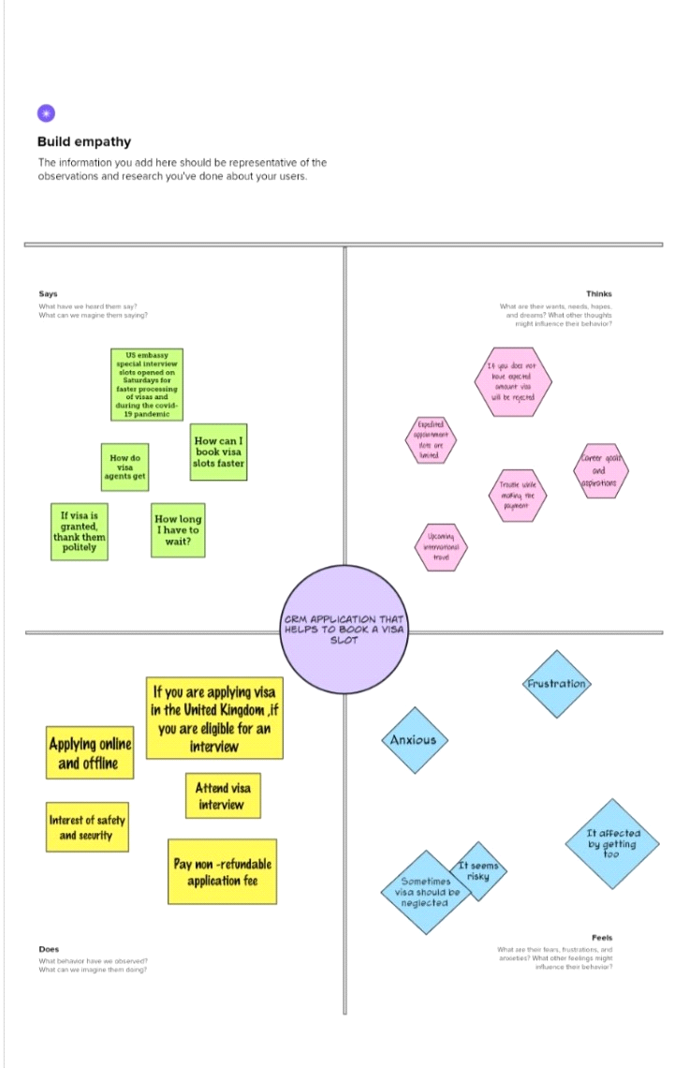
2.2 Ideation & Brainstorming Map:
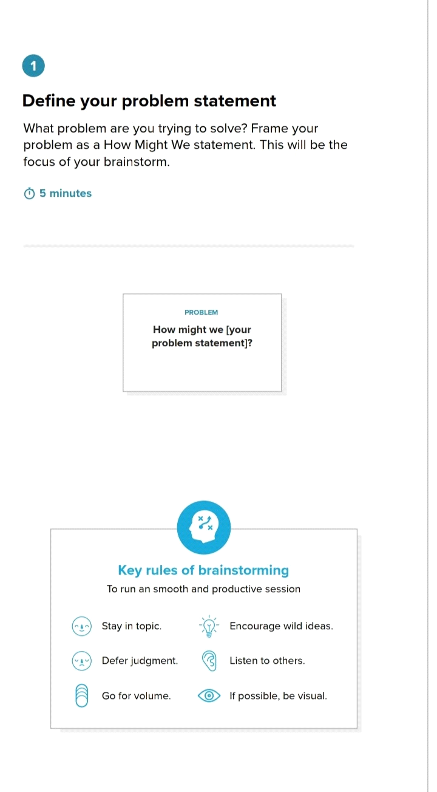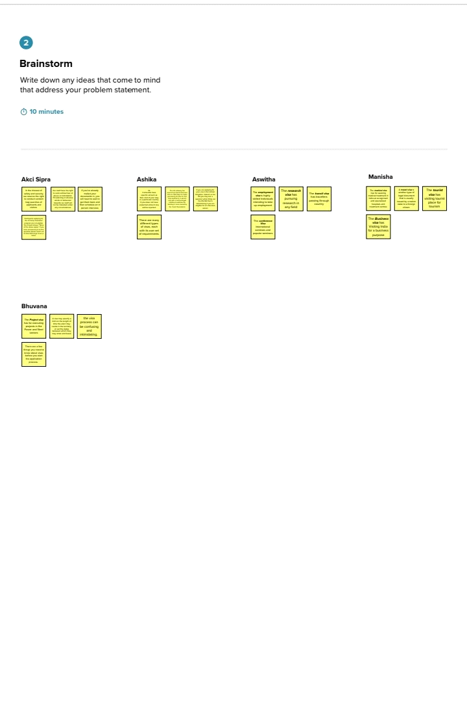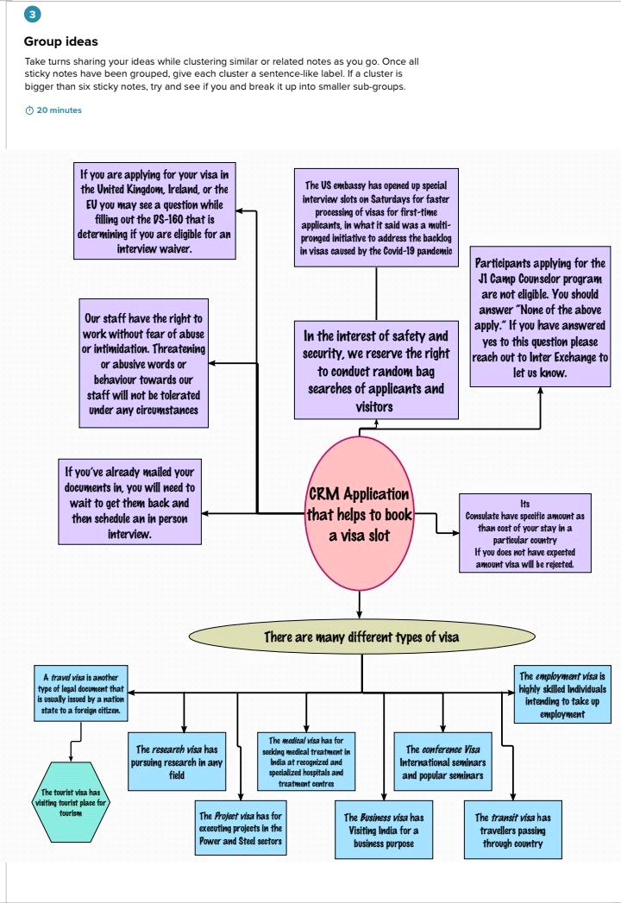

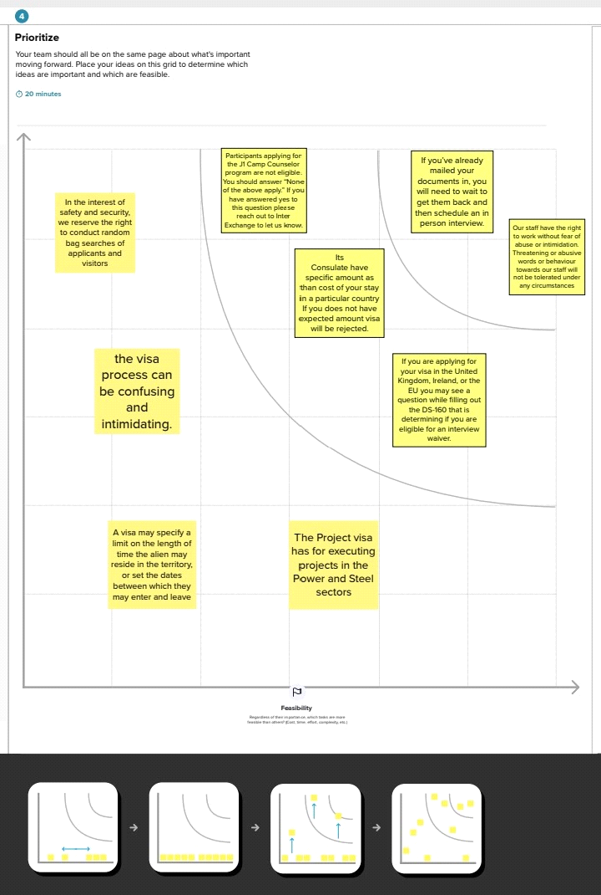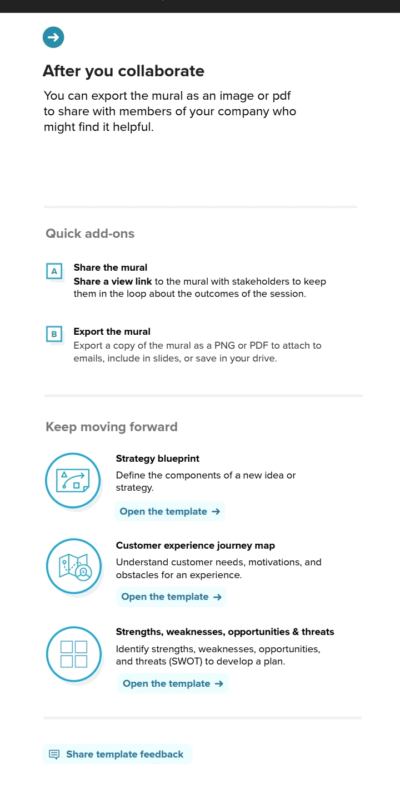

3 RESULT
3.1 Data Model:
OBJECT NAME | FIELDS IN THE OBJECT
Passport
  Field labal | Data type
  Full name | text
  Passport number | text
  Contact number | number
  Permanent address | text
Visa Slot
  Field labal | Data type
  location | Text
  Time | Text
  Passport number | Master
  Visa slot | Number
Payment
  Field labal | Data type
  Payment mode | Text
  Card number | Number
  Transaction id | Number
  Cancel transaction | Text
  Visa slot number | Master
Reschedule/Cancel
  Field labal | Data type
  Passport number | Master
  location | Text
  Time | Text
  Cancel | Text
  status | Text

3.2 ACTIVITY AND SCREENSHOT
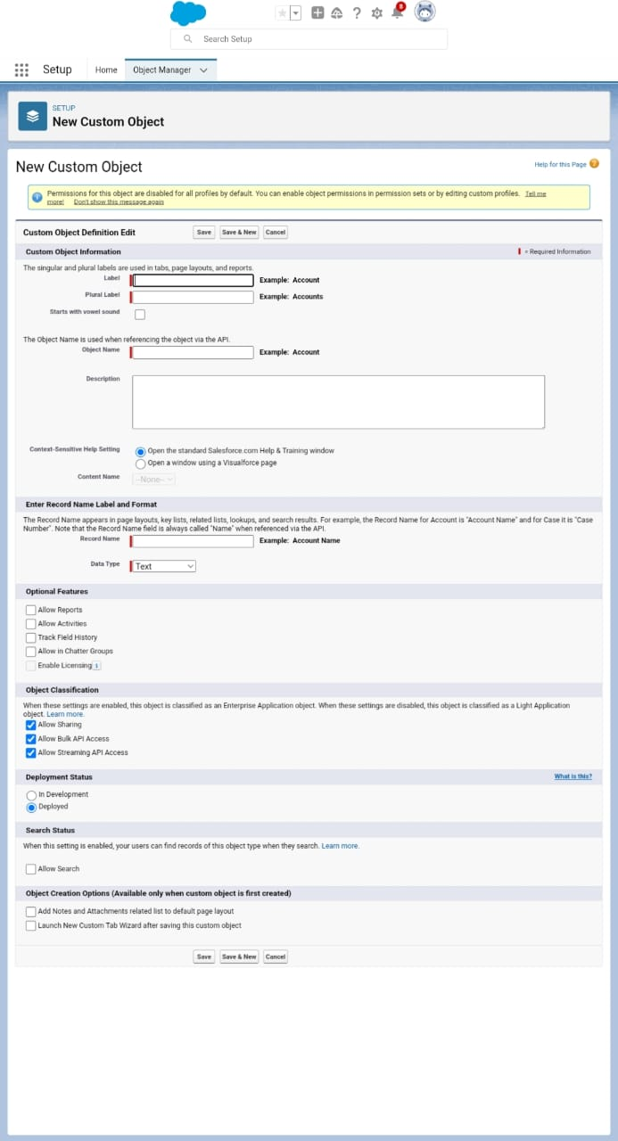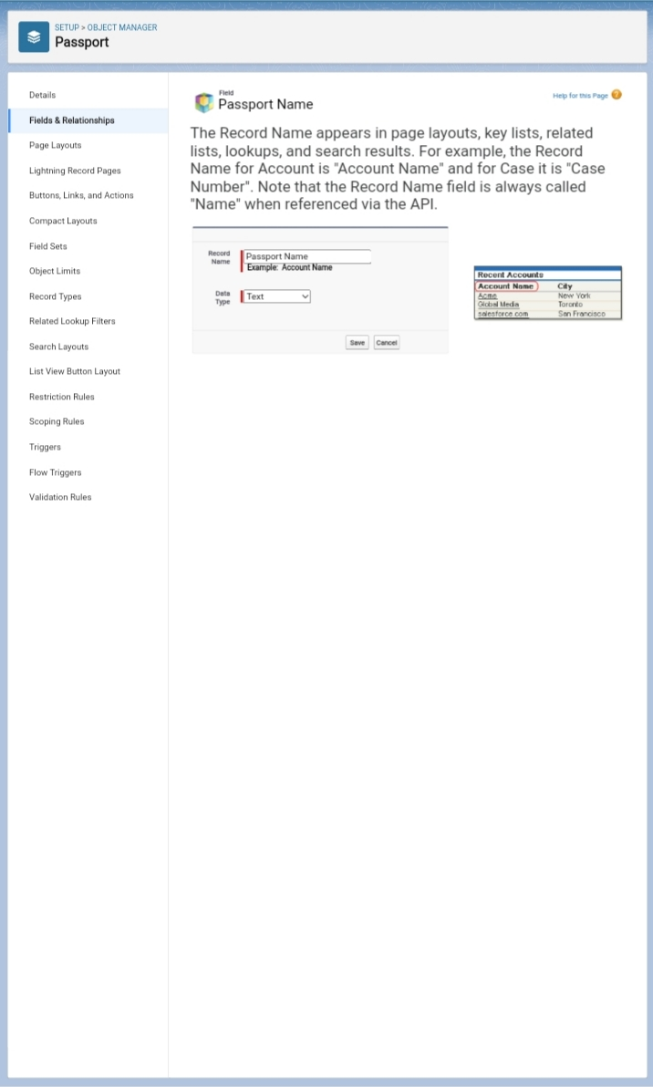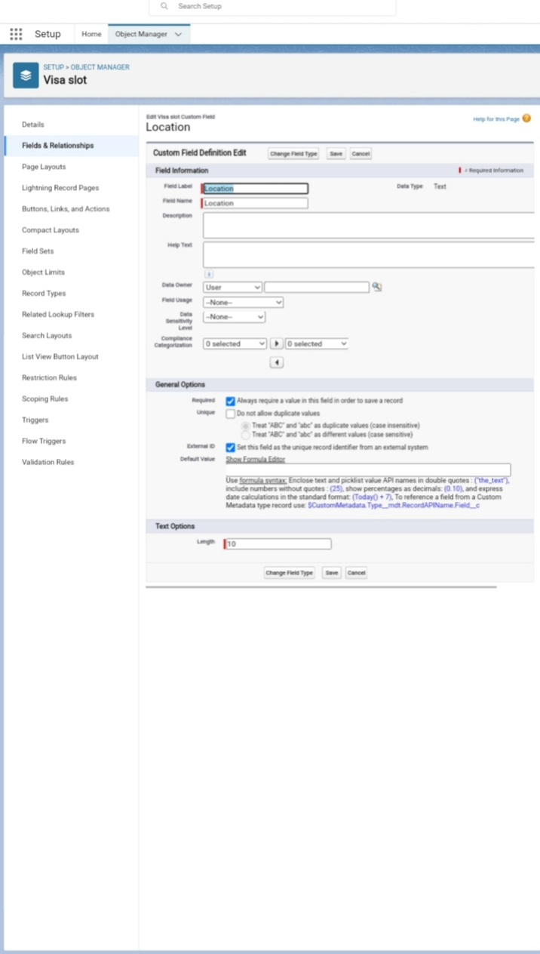

We have created a custom object and field and relation in passport and visa slot with payment.

4. Trailhead public URL:
Team lead: https://trailblazer.me/id/asiprap
Team member1: https://trailblazer.me/id/ashi0402
Team member 2: https://trailblazer.me/id/manisha2255rv
Team member3: https://trailblazer.me/id/strailhead
Team member4:https://trailblazer.me/id/aswitha2003

5. ADVANTAGES and DISADVANTAGES :

. Automate the Booking of Appointments With a visa slot booking bot, you can easily automate the process of booking visa appointments. ...
· Reduce Your Costs Managing your visas manually can be an expensive process due to the amount of time that it takes to do everything yourself. ...
· Get Real-Time Updates ...
· Reduce Processing Time .

- APPLICATION

Choosing CRM for immigration consultants can solve 90% of the problems which you are facing. If you have different sources for lead generation and facing issues in managing then you can manage all your things in one place. Over recent decades, the immigration & visa consultation industry has witnessed staggering growth. Given the momentum of people migrating from one country to another, the scope for immigration services is widened expeditiously. Thereby, more and more visa consultancy agencies take birth every day to flood the market and competition rate.

- CONCLUSION:

It is important to choose the right CRM technology for your business, as the efficient functioning of your business processes and employee productivity will depend on the technology adopted. It is also imperative that the solution you choose can sustain your business in the long term and continue to support your operations as you scale.

- FUTURE SCOPE

he scope of CRM includes a wide range of activities, from managing customer contact information to developing personalized marketing campaigns. In order to be effective, CRM must be tailored to the specific needs of each business. As such, the scope of CRM can vary greatly from one company to the next.

